Introduction:
In this lab I will continue my dive into Linux Basics by applying regular exression (regex) to log analysis. Regex is a powerful pattern-matching tool that is essential in the cybersecurity profession. Use cases such as detection of intrusion attempts, analyzing malware behavior, and extracting indicators of compromise (IoCs) from log files are routinely tackled by security analysts with regex. This lab will focus on useful regex applications in real-world log analysis scenarios.
To wrap my head around regex in this lab I will construct regex for pattern matching, combine regex with gre for advanced log analysis, identify security-relevant patterns in log files, then extract those patterns, and finally combine this all to apply regex to real-world incident response situations.
Exercise: Extended Regular Expressions
OR operator, multiple attack pattern detection, port range matching, and complex IP pattern matching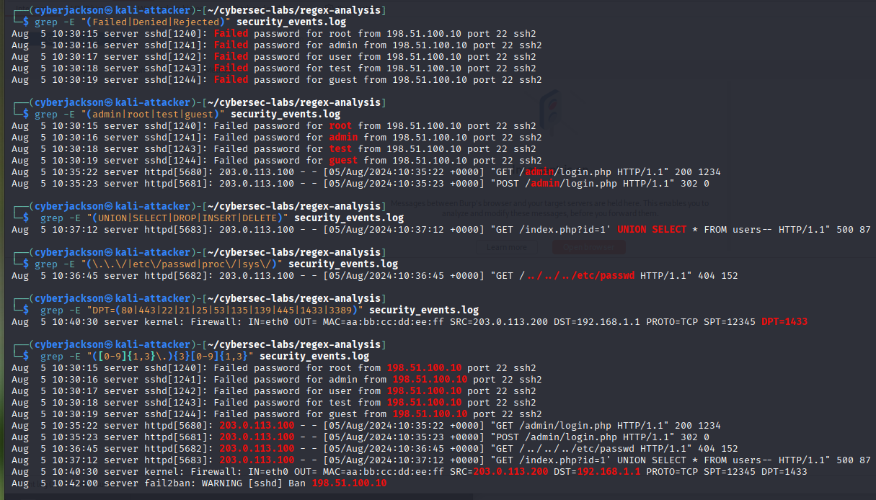
Advanced log parsing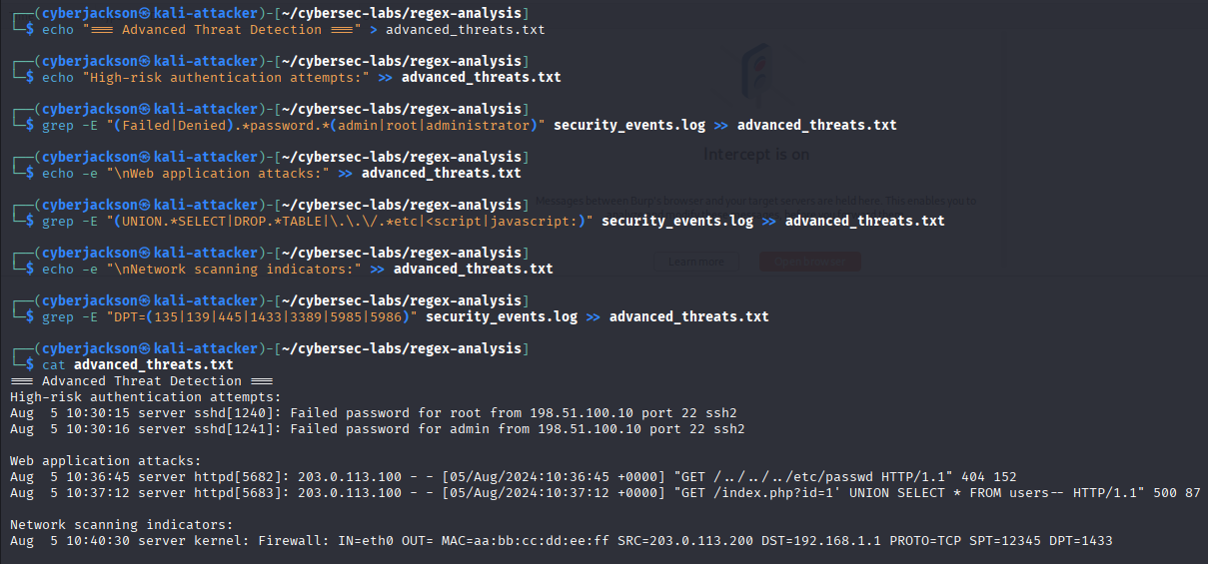

Exercise: Real-World Log Analysis Scenarios
Create incident response log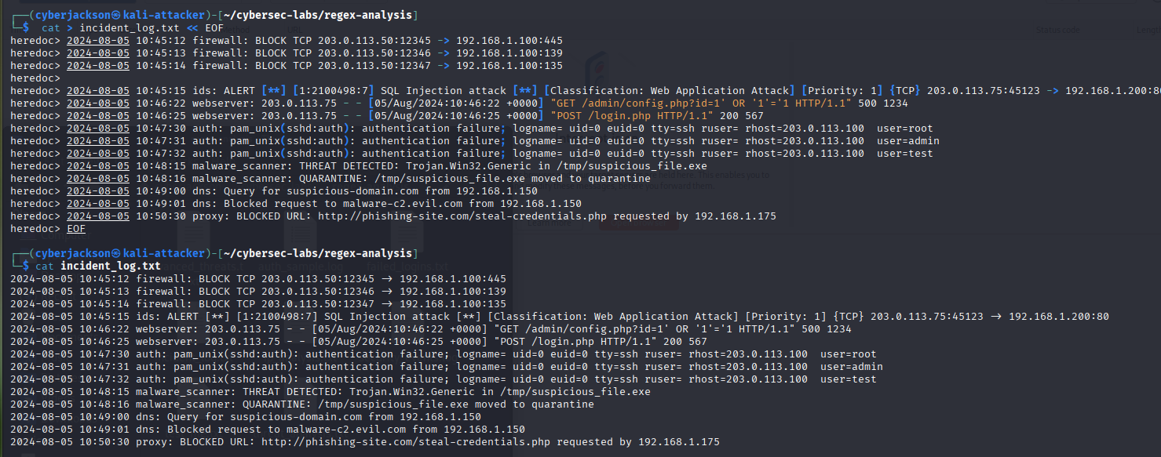
Complete Incident Analysis
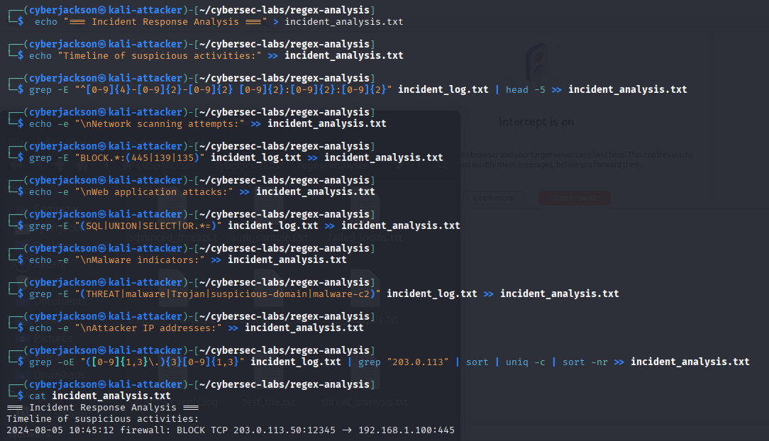
Create IoC (Indicators of Compromise) extraction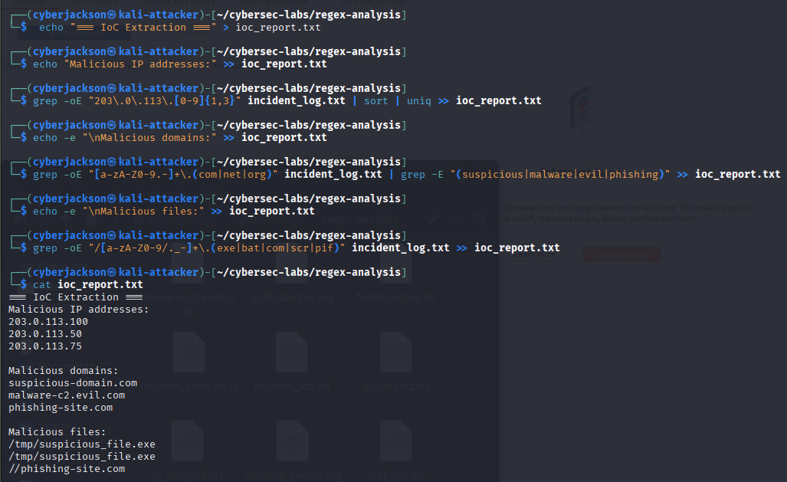
Conclusion:
In a previous computer science course, I had learned regular expressions and how to use them in java code to conduct similar parsing of strings. This lab was a great refresher for the concept of regular expressions and an even better opportunity to learn how they are applied in the Linux command line.
It is clear that regex is essential in cybersecurity and very powerful for analyzing security logs, forensic data, and other large datasets. The most interesting aspect of this lab and regex for me is how extended regular expressions allow us to do even more by combining expressions and using OR logic. These extended expressions which are built from the basic syntax of regex allow for much more specific yet complex parsing of logs.
The most difficult part of regex for me both before and after this lab is grasping the wide range of flags and delimiters and their accompanying syntax. More practice and work with regex will suffice in helping me here. Also, websites like regex101 allow me to play with and learn more about regex.

